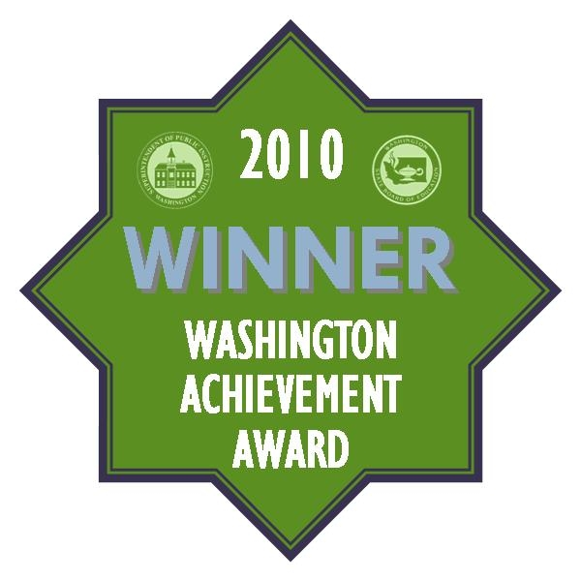
CVES is a 2010 Washington Achievement Award Winner
CASCADE VIEW ELEMENTARY SCHOOL has been selected a recipient of a 2010 Washington Achievement Award by the State Board of Education and Superintendent of Public Instruction. This award was created to celebrate the top-performing school and to recognize achievement in multiple categories. The Washington Achievement Award is given to elementary, middle, high and comprehensive schools in several different categories, including “OVERALL EXCELLENCE” for the top 5% of schools in the state. This award is a credit to our outstanding staff who strives daily to improve what they do in order for our children to achieve at the highest levels possible.

Of the 295 school districts in the state of Washington, there are only 4 districts who have 40% or more of their schools recognized for the “Washington Achievement Award”: The Snoqualmie Valley School District is well represented with the following schools also receiving this distinction . . . Fall City Elementary, Chief Kanim Middle School and Twin Falls Middle School. Congratulations to all of our students, teachers and community for their commitment and accomplishment.

