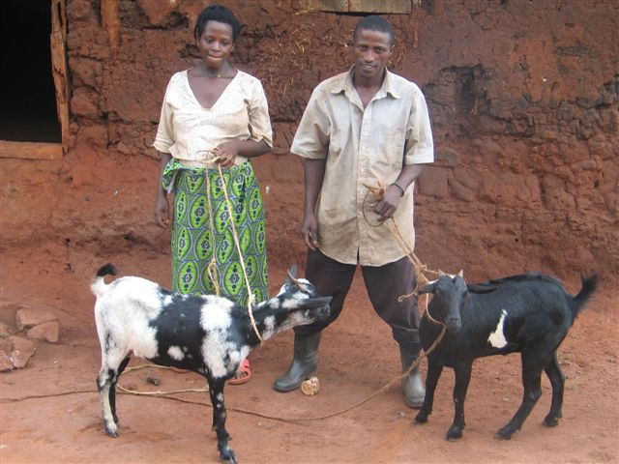
As a part of their study of Africa, the second grade classes at CVES
sponsored a month-long coin drive to buy goats for needy families in
Uganda. They collected over $400. The gift of a dairy goat serves as a
lasting, meaningful way for them to help families on the other side of
the world. A family expecting their first child has received the first
pair of goats. Soon a widow and another struggling young family will
receive their goats too.
Goats can thrive in extreme climates and on poor, dry land by eating
grass and leaves. A dairy goat supplies a family with up to several
quarts of nutritious milk a day - a ton of milk a year. Extra milk can
be sold or used to make cheese, butter or yogurt. Families learn to use
goat manure to fertilize gardens.
Goats often have two or three kids a year making it easy for goat
recipients to pass on the gift of a goat to another family in need. This
great investment allows families to lift themselves out of poverty by
starting small dairies that earn money for food, health care and
education.
Together, the second graders of CVES, learned that they could make a
real difference in Ugandan people's lives!

